Mobile Home Park

Strategic Business Plan

MOBILE HOME PARK

Business Plan

Table of Contents

1.0 Executive Summary 3
1.1 The Services 3
1.2 Financing 3
1.3 Mission Statement 3
1.4 Management Team 4
1.5 Sales Forecasts 4
1.6 Expansion Plan 4
2.0 Company and Financing Summary 5
2.1 Registered Name and Corporate Structure 5
2.2 Required Funds 5
2.3 Investor Equity 5
2.4 Management Equity 5
2.5 Exit Strategy 5
3.0 Mobile Home Park Operations 6
4.0 Strategic and Market Analysis 7
4.1 Economic Outlook 7
4.2 Industry Analysis 7
4.3 Customer Profile 7
4.4 Competition 8
5.0 Marketing Plan 9
5.1 Marketing Objectives 9
5.2 Marketing Strategies 9
5.3 Pricing 9
6.0 Organizational Plan and Personnel Summary 10
6.1 Corporate Organization 10
6.2 Organizational Budget 11
7.0 Financial Plan 12
7.1 Underlying Assumptions 12
7.2 Sensitivity Analysis 12
7.3 Source of Funds 12
7.4 General Assumptions 12
7.5 Profit and Loss Statements 13
7.6 Cash Flow Analysis 14
7.7 Balance Sheet 15
7.8 Breakeven Analysis 16
7.9 Business Ratios 16

1.0 Executive Summary

The purpose of this business plan is to raise and examine the allocation of $2.5 million for the development of a mobile home park based in Tampa, Florida. Mobile Home Park, LLC (“the Company”) intends to develop a 25 unit park within this market. The Company will recognize substantial monthly fees from rental as well as usage of onsite facilities. The Owner of the Company is Peter Smith.

1.1 The Services

As stated above, the Company intends to place 25 mobile home units on a fifteen acre parcel within the greater Tampa metropolitan area. Given the demand for affordable housing in this market, the Company anticipates an immense return on investment from these operations. The units offered will be double-wide mobile homes.

In addition to generating income from mobile home rentals, the location will feature numerous vending machines, washers, and dryers for tenant usage. As a value added benefit, the Company will provide free Wi-Fi. This will create a strong differentiating factor when marketing the Mobile Home Park to the Tampa community.

The third section of the business plan will outline the operations of the Mobile Home Park.

1.2 Financing

The Founder is seeking to secure $2.5 million in the form of a conventional business loan. This document assumes that the Company will receive a 25 year loan that carries a 6% interest rate on the outstanding principal balance. Given the large tangible asset base and highly recurring streams of revenue from mobile home rentals, the Company could easily secure additional financing in order to place additional units on the initial campus. In the event that Management wishes to establish additional location, the Company can leverage its equity position in the initial park. There are no immediate plans to scale the operations of the business past one campus.

Principally, the financing will be used for the following:

- 15-acre parcel acquisition
- 20 mobile home units
- Initial marketing

1.3 Mission Statement

Management’s mission is to provide affordable housing solutions for people within the greater Tampa metropolitan area while providing a host of amenities not commonly found at mobile home parks.

1.4 Management Team

Peter Smith is an experienced mobile home park owner-operator that has developed three locations during the course of his career. He will be able to properly launch the operations of this business to profitability with a focus on ensuring 100% occupancy at all times.

1.5 Sales Forecasts

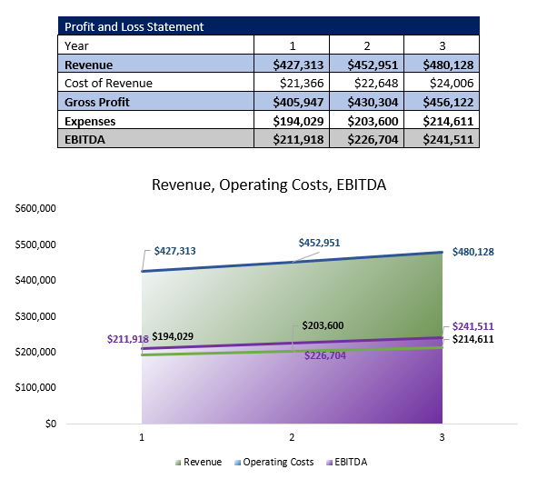

1.6 Expansion Plan

Once the location reaches 100% occupancy, Management may seek to develop additional mobile home facilities within other economically viable markets in Florida. The business may also seek other locations within the Southeastern or Midwestern United States as affordable housing remains in immense demand within these markets as well. The development of additional facilities would not occur until after the third year.

2.0 Company and Financing Summary

2.1 Registered Name and Corporate Structure

Mobile Home Park, LLC.

2.2 Required Funds

Management is seeking to secure a lending commitment of $2.5 million in order to carry out the objectives in this document. The funds are to be used as follows:

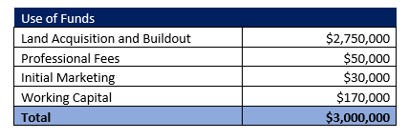

2.3 Investor Equity

Peter Smith will invest the entirety of the equity capital needed for this development. In the future, equity partners may be sought for expansion.

2.4 Management Equity

The above named Owner is the sole member of Mobile Home Park, LLC.

2.5 Exit Strategy

If it is economically viable to do so, the Mobile Home Park (all assets) would be sold to a third party. Typically, mobile home parks have a P/E ratio of ten times earnings. This includes the full sale of real estate and any land. In this event, a qualified real estate brokerage that specializes in commercial property would handle the sale on behalf of the business.

3.0 Mobile Home Park Operations

As stated in the executive summary, Management intends to develop a 25-unit facility on a beautifully styled 15-acre campus in Tampa, Florida. Management is currently coordinating with a commercial real estate brokerage that is seeking a property within this market area. Ultimately, the Company wants to place the location near the Gulf of Mexico as the close proximity to water will allow the Company to charge higher rental fees. The Company’s double wide trailers are expected to cost $80,000 to $120,000 each.

In regards to rent roll, the Company anticipates that it will generate $1,200 to $1,500 per unit depending on size. The business will require that tenants provide a credit report. Only prospective tenants that have a credit score of 650 or higher will be eligible. The income of tenants must be four times the aggregate yearly rental fees.

Beyond the rental income, the business will place food and beverage vending machines on the property as an ancillary center. Washers and dryers will also be available for tenant use. High speed internet, via Wi-Fi, will be available as well as a value-added benefit for tenants.

4.0 Strategic and Market Analysis

4.1 Economic Outlook

Currently, the economic outlook of the US economy is positive. Interest rates, while still high, have continued to decrease as inflation has become more tempered. The US Federal Reserve has indicated that they will most likely conduct interest rate decreases over the next twelve months in order to prevent an economic recession.
It should be noted that any potential issues with the economy will not impact Mobile Home Park’s ability to maintain 100% occupancy. The demand for affordable housing in Tampa and its surrounding market areas remains strong. The cost of renting a mobile home unit is affordable among lower to lower-middle income families in this market.

4.2 Industry Analysis

There are approximately 50,000 operators of mobile home parks within the United States. These entities operate in a few different capacities. Some mobile home units are owned directly by their occupants, but they lease the underlying land. The Company is employing a rental business model that will allow the business to generate highly recurring streams of monthly revenue.

Aggregately, these entities generate in excess of $5 billion per annum. This industry’s growth will remain similar to that of the economy as a whole.

4.3 Customer Profile

Management will use the following profile when marketing the Mobile Home Park to the Tampa general public:

- Household income not exceeding $45,000
- FICO score of at least 650
- Will provide a $500 to $1,000 security deposit
- Can afford $700 to $1,000 per month in rent

In the customer profile section, you can further indicate important market statistics about your specific area. These statistics including median household income, the regional unemployment rate, number of housing units in the market, and the ongoing demand for affordable housing. You can use publicly available information from the US government via the census website for these purposes. There are also a number of private information sources that can provide demographic information based on region and ZIP code.

4.4 Competition

Given the immense demand for affordable housing in the greater Tampa metropolitan area, the ongoing competitive issues that the Company will face are relatively low. The business intends to develop a campus that will feature a number of amenities that are not commonly found at competing locations.

In the competitive section of the business plan, you should focus on the ways that your mobile home park will be different than competitors. You can also include information about existing businesses in the market, how much they charge for rent, and other characteristics.

5.0 Marketing Plan

Foremost, the Company intends to showcase the high-end nature of the double wide mobile homes offered to the Tampa general public. The business will use a number of marketing strategies that will ensure that the business reaches 100% occupancy by the third month of operation.

5.1 Marketing Objectives

- Partner with organizations that help people find affordable housing within the Tampa area.
- Launch an online marketing campaign prior to the grand opening of the facilities in order to have tenants enrolled once the development is completed.
- Partner with real estate brokers that will directly place people at the Mobile Home Park or provide referrals when people are seeking affordable housing.

5.2 Marketing Strategies

Mobile Home Park, LLC will have a professionally developed website that showcases all available units. The Company will also retain a videography firm that will produce videos that showcase the campus, units, and amenities provided to tenants. The website will undergo regional search engine optimization specific for the Tampa market. This will allow the website to be quickly found when searches for mobile homes in Tampa are completed.

The Company will partner with not-for-profit groups that specialize in helping people find affordable housing. Given the demand for low-income housing in Tampa, the Company sees a substantial opportunity to receive referrals from these groups. Beyond these entities, the Company will establish ongoing relationships with real estate agents and brokers in this market area. The business will provide commissions that are equal to three months of rent for each new tenant placed at the location.
To a more moderate extent, the Company will maintain a presence on social media platforms including Facebook and Instagram. The Company will use targeted social media advertisement when vacancies occur. These advertisements will be geared towards people that have sought affordable housing in the Tampa area.

It should be noted that that all above marketing strategies will be implemented prior to the launch of the facilities. Management anticipates that the business will have 50% occupancy from pre-enrollment.

5.3 Pricing

The Company will charge $1,200 to $1,500 per month depending on the size of the unit. The business will generate fees of $1 to $3 for usage of vending machines, washers, and dryers.

6.0 Organizational Plan and Personnel Summary

6.1 Corporate Organization

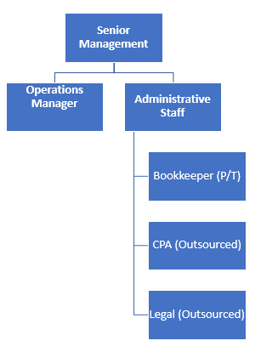

6.2 Organizational Budget

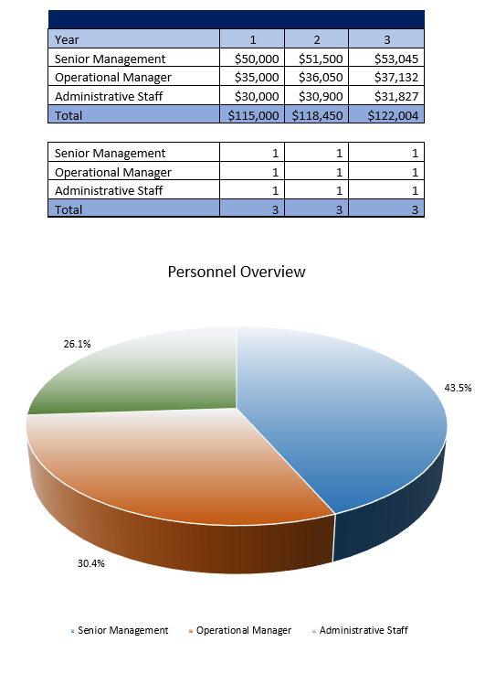

7.0 Financial Plan

7.1 Underlying Assumptions

The Company has based its proforma financial statements on the following:

- Mobile Home Park, LLC will acquire $2.5 million of debt capital to launch operations.
- The Founder will contribute $500,000 towards the venture.

7.2 Sensitivity Analysis

Within Tampa, the demand for affordable housing remains strong at all times. This is a population dense area, and the Company will have no issues maintaining 100% occupancy. This is expected to be achieved very quickly given this demand. The Mobile Home Park will have highly controllable operating costs, which will further ensure the economic stability of the location over a substantial period of time.

7.3 Source of Funds

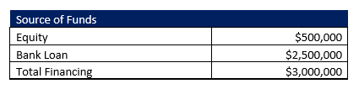

7.4 General Assumptions

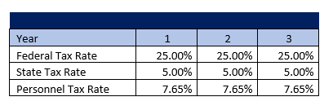

7.5 Profit and Loss Statements

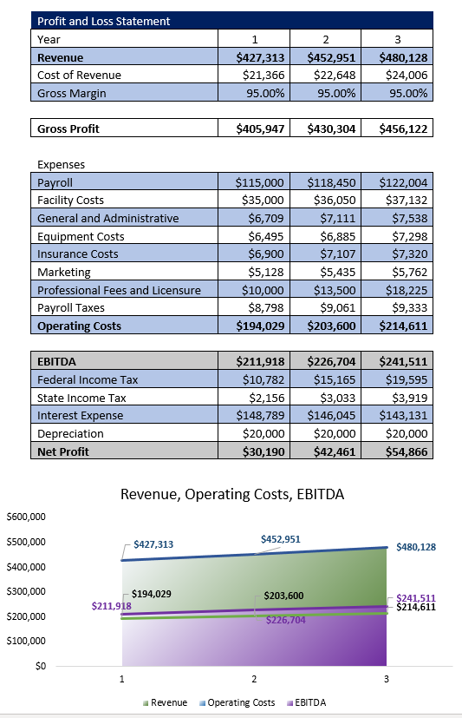

7.6 Cash Flow Analysis

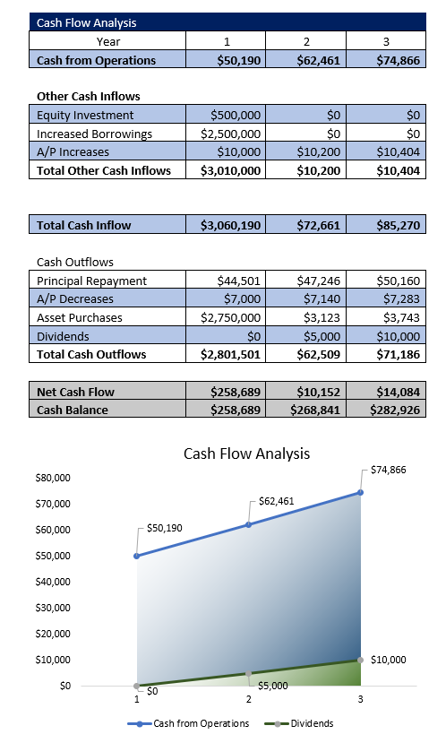

7.7 Balance Sheet

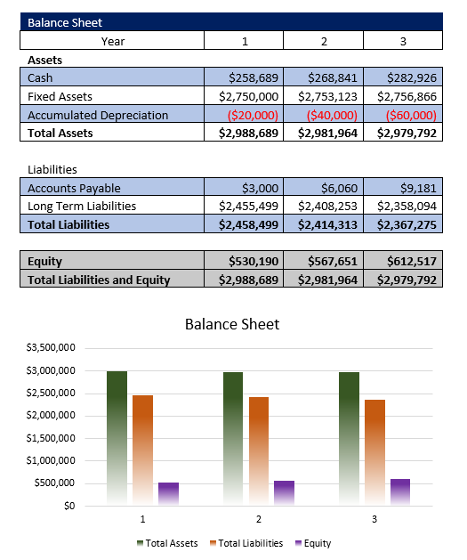

7.8 Breakeven Analysis

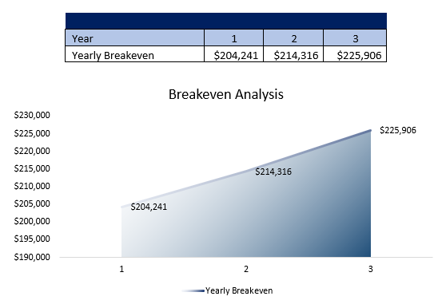

7.9 Business Ratios

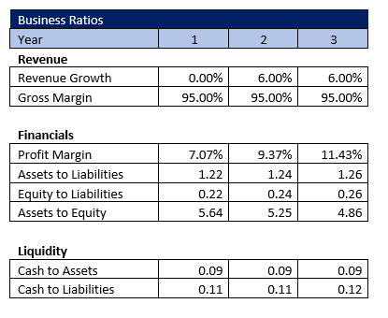



HumanIntelligenceBusinessPlans.com

We are a full-service business plan and pitch deck development company.

Please note that this is simply a template for a fictious business. All work completed for our clients is done specifically for their needs. No AI is used during the course of our work.

